MEMO
To: | Hunter and Central Coast Regional Planning Panel
From: | Chief Development Engineer - David Pavitt
Application number: | DA/1284/2013 | Your reference: | PPS-2013HCC016 | Date: | 27 November 2020
Subject: | Details on planning pathways for residential subdivision at Myall Road, Cardiff (DA/1284/2013 & PPS-2013HCC016)
Summary:
Consent is sought for a residential subdivision for 66 standard residential lots, three larger lots for future medium density housing, and three residue lots for conservation purposes.
At the briefing held on Wednesday 3 June 2020, the Hunter and Central Coast Regional Planning Panel (RPP) requested Council staff provide a memo to the RPP detailing the statutory and policy framework of the development. This memo responds to this request and details:
- Permissibility
- Minimum subdivision lot sizes
- Site Compatibility Certificate
- Environmental planning instruments
- Biodiversity conservation legislation

Permissibility
The following table outlines the permissibility pathways of the development.
Legislation | Discussion | Savings provisions | Permissible
Lake Macquarie Local Environmental Plan 2004 (LMLEP 2004).  The application was lodged under LMLEP 2004 on 26 August 2013. | A majority of the land was shown on the LEP maps as ‘deferred’ (refer to Appendix 1).  Under clause 2 of LMLEP 2004, the LEP does not apply to land shown as “Deferred” on the map. | N/A – deferred land (refer to LMLEP 1984) | N/A
 | Land not mapped as ‘deferred’ under LMLEP 2004 is zoned under LMLEP 2004 as follows:  - 6(1) Open Space  - 7(2) Conservation (Secondary) Zone  Refer to Appendix 1.  Subdivision of land is permitted with consent under clause 24 under LMLEP 2004, with minimum lot sizes specified in Schedule 2. | Yes – cl1.8A LMLEP 2014 | Yes - cl24 & Schedule 2 LMLEP 2004
Lake Macquarie Local Environmental Plan 2014 (LMLEP 2014).  LM LEP 2014 commenced in September 2014. | Under clause 1.8A of LMLEP 2014 savings provision apply to underdetermined development applications that have been made before the commencement of the plan in relation to land to which the plan applies. | Yes – cl1.8A LMLEP 2014 | N/A
Lake Macquarie Local Environmental Plan 1984 (LMLEP 1984). | Land mapped as ‘deferred’ under LMLEP 2004 is zoned under LMLEP 1984 as follows:  - 1A Rural  - 2A Residential  - 2B Residential  - 3C Neighbourhood Business  - 5C Special Uses (Proposed Local Road Reservation)  - 6A Open Space (Public Recreation)  - 6B Open Space (Special Recreation)  - 6C Open Space (Local Reservation)  Refer to Appendix 2.  Subdivision of land is permitted on any land with consent under clause 11 of LMLEP 1984. | N/A | Yes – cl.11 LMLEP 1984

Minimum subdivision lot sizes
The following table outlines the permitted minimum subdivision lot sizes for the development.
Legislation | Discussion | Complies
Lake Macquarie Local Environmental Plan 2004 (LMLEP 2004). | Minimum subdivision lot sizes under LMLEP 2004 for land not mapped as ‘deferred’ under LMLEP 2004 are as follows:  - 6(1) Open Space – No minimum lot size  - 7(2) Conservation (Secondary) Zone – 40ha  The 7(2) portion of the site is approximately 1.3ha, and does not comply with the minimum lot size. This portion of the site will be amalgamated in proposed Lot 72 (the residue biodiversity offset lot) which has an area of 21.43ha.  A SEPP 1 objection to the development standard has been submitted to support the variation to the minimum 7(2) lot size. The SEPP 1 objection has been reviewed and is supported by Council. | Yes
Lake Macquarie Local Environmental Plan 1984 (LMLEP 1984). | Minimum subdivision lot sizes under LMLEP 1984 for land mapped as ‘deferred’ under LMLEP 2004 applies only to the Rural 1A zone. All other zones do not have a minimum subdivision lot size.  The minimum subdivision lot size for Rural 1A zone is 40ha.  The Rural 1A land portion of the site, located north of Myall Road, is approximately 1.65ha, and does not comply with the minimum lot size. The application proposes to create two lots from this land being proposed Lot 69 for future residential development (0.88ha), and proposed Lot 70 for biodiversity offset (0.77ha).  As an alternate avenue to varying the minimum lot size, the applicant obtained a Site Compatibility Certificate (SCC). For discussion, refer to SCC. | No – refer to SCC discussion

Site Compatibility Certificate
To address the non-compliances with the minimum Rural 1A subdivision lot size identified above, a Site Compatibility Certificate (SCC) was applied for and issued under clause 18 and 19 of State Environmental Planning Policy (Infrastructure) 2007 (ISEPP). The extent of lands included within the SCC is shown in Appendix 3.
The following table outlines the key elements of the ISEPP in relation to the development.
Clause | Part | Discussion | Complies
18 Additional uses of certain State land permitted |  | The land is owned by the State of NSW and currently is being administered by the New South Wales Land and Housing Corporation. | Yes
 | 1(a) Applies to State land unless the land is subject to a standard LEP | The application is subject to the provisions of LMLEP 2004 and LMLEP 1984 which are not standard local environmental plans.  LMLEP 2014 is a standard local environmental plan, however savings provisions apply as detailed previously. | Yes
 | 1(a) Applies to State land unless the land is zoned for conservation purposes, state forest, reserved for national parks, reserved under Crown Lands Act. | The development footprint does not include development on land covered for these purposes. | Yes
 | 2 & 3 Enables development of State land to be carried out similarly to adjoining zoned land, subject to a SCC being issued. | A SCC has been issued for the development on 7 September 2012, and again on 6 October 2017. The current SCC is due to expire on 6 October 2022 (five years from the date of issue).  The SCC certifies the development of the site for:  - 70-80 dwellings in southern precinct, and  - 20-25 dwellings in northern precinct.  and is compatible with the surrounding land uses and is not likely to have an adverse effect of the environment and does not cause any unacceptable environmental risks to the land.  Refer to Appendix 3 and Appendix 4.  The application proposes development that is consistent with the SCC, as follows:  - single future residential development lot in the northern precinct which enables 20-25 dwellings;  - 66 residential lots and two future development lots in the southern precinct.  To remain consistent with the SCC future development lots in the southern precinct will be therefore be limited to a maximum yield of 14 dwellings. | Yes

Environmental planning instruments
The following table outlines the applicable environmental planning instruments (EPI’s) including SEPPs and LEPs.
EPI | Discussion | Savings provisions | Comparison to current EPI
State Environmental Planning Policy No. 1 – Development Standards | The application proposes to vary the minimum 7(2) lot size under LMLEP 2004.  A SEPP 1 objection to the development standard has been submitted to support the variation to the minimum 7(2) lot size. | Yes – cl.7 State Environmental Planning Policy (Concurrences and Consents) 2018 | SEPP 1 has been repealed, and replaced with the provisions of clause 4.6 of the Standard Instrument.  Clause 4.6 contains different content, however maintains the same intent for consideration of variations to development standards.
State Environmental Planning Policy No. 19 – Bushland in Urban Areas | The development adjoins land zoned 6(a) Open Space (Public Recreation) and 6(1) Open Space, and is located on land zoned 6(c) Open Space (Local Reservation).  The policy applies to Lake Macquarie.  Clause 6(4) applies to land zoned for bushland or public open space and requires the consent authority to:  - consider the need to protect and preserve bushland,  - be satisfied disturbance of bushland is in the public interest and there is no reasonable alternative,  - be satisfied the amount of bushland disturbed is minimised.  Clause 9(2) applies to land adjoining land zoned for bushland or public open space and requires the consent authority to:  - consider the need to retain bushland,  - effect of the proposed development on bushland or public open space.  The development protects and preserves land zoned for, and land adjoining, bushland and public open space purposes as a large part of the site will be dedicated as a biodiversity offset site. Disturbance of this land will be minimised with all development works contained within the area approved with the SCC. | Nil | SEPP 19 remains in force.  Clause 6(4) and 9(2) are materially the same.
State Environmental Planning Policy No. 55 – Remediation of Land | A preliminary contamination assessment has been undertaken which has identified a number of localised areas of potential contamination from minor filling and illegal dumping.  The potential contamination is capable of being remediated by offsite disposal to a licensed landfill after undertaking a waste classification.  A detailed contamination assessment and Remediation Action Plan will be required prior to construction commencing.  Following these remediation works, the land will be suitable for the purpose of which is proposed. | Nil | SEPP 55 remains in force and is materially the same.
State Environmental Planning Policy (Infrastructure) 2007 | Clause 18(3) states consent must not be granted unless the consent authority is satisfied a SCC has been issued.  The development is subject to a SCC issued under clause 19 of the ISEPP, and consent may be granted for the purposes detailed in the SCC.  Refer to SCC discussion. | Yes - cl.11 ISEPP  SCC valid until 6 October 2022. | ISEPP remains in force.  Clause 18 and 19 have been rewritten but remain materially the same.
State Environmental Planning Policy (State and Regional Development) 2011 | Clause 20 stipulates the application of the SEPP to development included in Schedule 4A of the Act.  Schedule 4A of the Act applies to Crown development with a CIV over $5 million.  The development has a value of ($5,115,000) and is therefore Regional development and to be determined by the RPP. | Nil applicable to the development. | The SEPP remains in force.  Clause 20 has been rewritten and enacts the provision of Schedule 7 which now sets out regionally significant development (moved over from the Act).  The SEPP provisions remain materially the same.
State Environmental Planning Policy No. 44 - Koala Habitat Protection | The policy applies to Lake Macquarie.  The land has an area of more than one hectare, and is subject to the provisions of the SEPP.  An assessment of the land against the SEPP has been included in the Biodiversity Assessment Report, and concluded the site is not core koala habitat. | Yes  State Environmental Planning Policy (Koala Habitat Protection) 2019 commenced on 20 December 2019, and repealed SEPP 44.  Clause 15 of the SEPP contains savings provisions. | The (new) Koala SEPP maintains the same aim to protect koala habitat.  The SEPP provisions remain materially the same as follows:  - applies to land more than 1ha,  - requires consideration to guidelines and provisions to assess potential and core koala habitat and impact of development.
Lake Macquarie Local Environmental Plan 2014 (LMLEP 2014). | LMLEP 2014 commenced in September 2014 following the lodgement of the application.  Savings provisions apply to the application under clause 1.8A of LMLEP 2014.  Consideration to the draft EPI will be detailed in the assessment report. | Yes – cl1.8A LMLEP 2014 | Under LMLEP 2014 the land is zoned as follows:  - RE1 Public Recreation (no minimum lot size);  - E2 – Environmental Conservation (40ha minimum lot size).  Subdivision of land is permitted with consent under clause 2.6, minimum lot sizes specified on the Lot Size Map.  The RE1 and E2 portions of the site will be amalgamated in proposed Lot 72 (the residue biodiversity offset lot).  Clause 4.1E of LMLEP 2014 allows lots to be approved that are less than the minimum lot size shown on the lot size map if the consent authority is satisfied that  - the subdivision will facilitate the long-term biodiversity conservation management of the lot, and  - suitable arrangements have been, or will be, made for the long-term protection, conservation and management of the lot, and  - the subdivision will not create the opportunity for additional dwellings on any of the lots  - the subdivision will not require the clearing of any native vegetation other than native vegetation required to be removed for the long-term protection, conservation and management of the lot.  The application proposes to offset the RE1 and E2 zoned lands for the purposes of conservation, which will have arrangements for ongoing protection and management. No vegetation clearance is required within these lands.  The application will not create the opportunity for additional dwellings.  All other zoning and minimum lot size provisions remain materially the same as those in LMLEP 2004.

Biodiversity conservation legislation
The following table outlines the biodiversity conservation pathways of the development.
Provisions | Discussion | Savings provisions | Comparison
Environmental Planning and Assessment Act 1979  5A Test of Significant effect on threatened species, populations or ecological communities, or their habitats | In consideration a development application proposed under s79C of the EPA Act, clause 5(a) requires consideration of a development’s impact against the provisions of the clause, and the assessment guidelines contained in the Threatened Species Conservation Act 1995 (TSC).  An assessment of the development against provisions of the Act, including TSC guidelines has been included in the Biodiversity Assessment Report and Addendum Biodiversity Assessment Report.  The development is considered to not present a significant impact on threatened species, populations or ecological communities, or their habitat.  A Species Impact Statement (SIS) has therefore not been requested. | Yes  The Biodiversity Conservation Act 2016 (BC) commenced on 23 November 2016 with the biodiversity offset scheme commencing within the LMCC LGA on the November 28 2018.  Schedule 9 of the BC Act and clause 28 of the Biodiversity Conservation (Savings and Transitional) Regulation 2017 contains savings provisions that enable the former planning provisions to continue to apply. | The EPA act remains in force. Clause 1.7 (ex. 5A) has been rewritten and enacts the provision of BC Act.  The (new) BC Act:  - requires applications to avoid and minimise significant habitat and complete a test of significance that is essentially the same as that which has been applied to the site under the former planning provisions;  - identifies land of Biodiversity Value (BV).  Mapped BV areas do not occur on the Myall Road site;  - introduces a Biodiversity Offsetting Scheme (BOS).  The application would have triggered clearing thresholds under the BC Act if the BOS was applied.  Regardless, the application proposes offsets.
David Pavitt
Chief Development Engineer
Development Assessment and Certification
Appendix 1 – LMLEP 2004 Land use map
The figure below shows the:
- deferred lands (shown in solid white)
- site (outlined in blue)

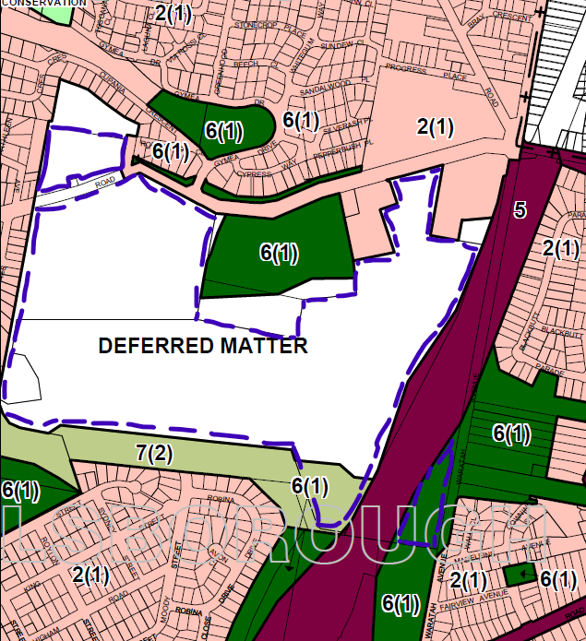

Appendix 2 – LMLEP 1984 Land use map
The figure below shows the:
- development footprint (outlined in red)
- site (outlined in blue)
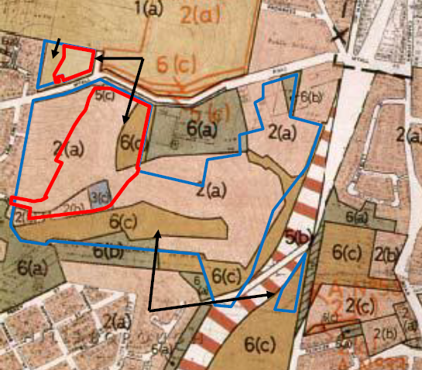

Appendix 3 – Site Compatibility Certificate
The figure below shows the:
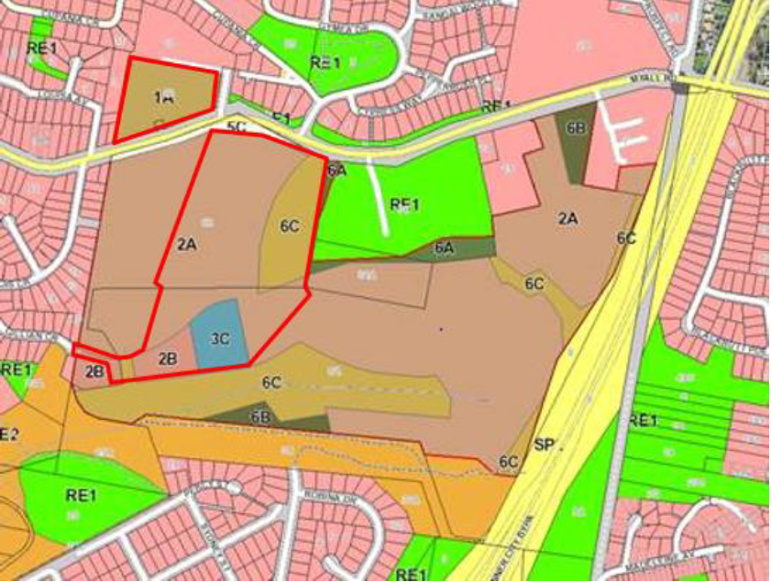
- SCC footprint (outlined in red)

Appendix 4 – Site and precinct identification plan
